Episode 606: Heat engines and thermal efficiency

This material is only relevant to some specifications so check carefully before covering it.
Lesson Summary
- Discussion and demonstration: Steam engines (10 minutes)
- Student activity: Finding out about thermal efficiencies (20 minutes)
- Discussion: The Second Law and efficiency (15 minutes)
- Worked examples and student questions: Calculating efficiency (20 minutes)
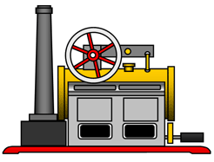

Discussion and demonstrations: Steam engines
If you have a model steam engine it would be excellent to show this and consider the changes to the way energy is stored when it is used. Emphasise that energy is dissipated (wasted) when, for example, steam emitted from the chimney heats the surroundings. If you do not have a steam engine, try to find a video or other resources relating to a power station. In all cases there should be energy stored in the fuel (and oxygen) that (usually) generates steam.
The steam drives a turbine and then is condensed and returned to the boiler. A significant proportion of the energy stored thermally in the steam is not delivered to the turbines and it is then wasted in heating up the coolant in the condenser. That coolant may then itself be used as a source of energy (in Combined Heat and Power stations) improving the overall efficiency of the power station.

Student activity: Finding out about thermal efficiencies
Use the web or printed information from energy companies to find out about the efficiency of different types of power stations. Use these to discuss the meaning of the definition of efficiency = useful energy outtotal energy in × 100 %.
Clearly without the word useful the efficiency would be 100% in all systems. (Why? Because energy is conserved)
Can students think of a system that is 100% efficient? If not, lead them to thinking about systems where heating is the intended change – such as a radiator or electrical fire. How does a coal fire compare (energy loss up the chimney)?
Can they draw up a quantitative Sankey diagram for a power station?
Episode 606-1: Power station efficiencies (Word, 30 KB) - see end of document

Episode 606-2: Sankey diagrams (Word, 158 KB) - see end of document

Discussion: The Second Law of Thermodynamics and efficiency
Ultimately, justification of the Second Law of Thermodynamics rests on an understanding of entropy. Without a full-blown mathematical proof, which is inappropriate at this level, it is necessary to rely on assertion and justification by reason. A simple statement of the Second Law is that you cannot have a process whose only effect is to use energy stored thermally to do work. If you could, you could build a car which extracted energy from the air and drive along without needing petrol. This limitation is fundamental, not merely a practical constraint.
In a power station the working fluid (water or steam) is allowed to expand through the turbines and so drive them. Afterwards the expanded steam needs to be returned at low pressure by cooling in order to complete a cycle – to put it back as it was before it entered the boiler. Hence the need to cool the steam in the condenser. This energy is not useful. Thus, although we can use some energy stored thermally to do work we cannot extract all of it.
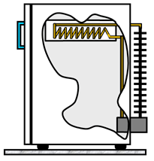
Consideration of cycles like those in a power station (a heat engine ) shows that the maximum efficiency of such a device is given by T_{hot} − T_{cold}T_{hot}. In this equation T is in K, the absolute temperature .
Finally, you may need to mention the heat pump. This is simply a heat engine operated in reverse. Work shifts energy stored thermally in a cold reservoir to energy stored thermally in a hot one. The details are not needed, but a refrigerator is an example. Heat pumps are sometimes used to heat houses in cold climates. They can be very effective.

Worked examples: Calculating efficiency
1 Calculate the maximum theoretical thermal efficiency of a coal-fired power station that heats steam to 510 ° C and cools it in a condenser at 30 ° C.
Answer:
Maximum efficiency = T_{hot} − T_{cold}T_{hot}
Maximum efficiency = (510+273) K − (30+273) K(510+273) K
Maximum efficiency = 0.61, or 61%.
2 The temperature of the gases in a car engine during combustion is 1800 ° C. The exhaust is expelled at 80 ° C.
Calculate the maximum theoretical thermal efficiency of the engine.
Answer:
Maximum theoretical efficiency = T_{hot} − T_{cold}T_{hot}
Maximum theoretical efficiency = (1800+273) K − (80+273) K(1800+273) K
Maximum efficiency = 0.83, or 83%.
Of course, in both case, the actual efficiency will be smaller. Students should consider why.
Episode 606-3: Student questions; calculating efficiency (Word, 27 KB) - see end of document

Episode 606- 1: Power station efficiencies

Teachers may find it useful to have some web references to look at efficiencies of power stations. Here are a selection of articles from October 2005. More recent articles may be available online.

http://www-g.eng.cam.ac.uk/mmg/environmental/young2.html High efficiency power generation with low emissions

Quote from Prof John Young:
"The world's first power station generating electricity for public use was built in 1882 in Holborn Viaduct in London. Steam raised in a boiler (coal-fired with manual stoking, of course) was used to drive a reciprocating steam engine and the station efficiency was probably about 6%. Then came the more efficient steam turbine invented by Sir Charles Parsons (a Cambridge educated engineer) and this dominated the 20th century. Both coal and oil were used as fuel and by 1975 the efficiency of the best power stations was around 40%. In the 1980's, the discovery of large natural gas reserves, the development of heavy-duty industrial gas turbines and the de-regulation of the electricity supply industries all contributed to the development of the gas and steam turbine 'combined-cycle' resulting in a current best station efficiency of just under 60%. This huge efficiency improvement of almost 20 percentage points has occurred over the last 15 years and is an astonishing engineering achievement not fully appreciated by the public."

https://www.ge.com/content/dam/gepower-pgdp/global/en_US/documents/technical/ger/ger-3935b-power-systems-21st-century-h-class-gas-turbine-combined-cycles.pdf (NB 1.73 Mb PDF)

“GE’s H System is the first gas turbine combined-cycle system capable of breaking the 60% fuel efficiency barrier. Why is that so important? Fuel is the single largest cost of running a power plant, and even a 1% gain in thermal efficiency can mean as much as a $15 million to $ 20 million saving over the life of a typical plant of this size.”

http://www.genesisenergy.co.nz/genesis/generation/thermal-info/thermal-info_home.cfm Huntley power station New Zealand
“A new high efficiency combined cycle gas turbine power plant to be built at the existing Huntley site. This project is known as the Huntley Energy Efficiency Enhancement Project (Huntley e3p). The new power plant will utilise the latest thermal generation technology to generate up to
365 MW of electricity, bringing the potential generation at the Huntley site to 1365 MW. The Huntley e3p plant will be approximately 50% more energy efficient than the current generating technology at Huntley. While the existing station uses a simple steam turbine to generate electricity, the Huntley e3p uses a gas turbine first and then also converts what would otherwise be waste heat to electricity using a steam turbine.”

http://www.makingthemodernworld.org.uk/learning_modules/geography/06.TU.06/?section=6
“For example, a typical coal fired power station converts 3.45 MW of chemical power from coal into only 1.2 MW of electrical power. The difference (2.2 MW) is lost as heat. In reality it would be more accurate to describe a power station as a generator of heat rather than a generator of electricity!
Episode 606- 2: Sankey diagrams

Energy transfers can be complex. Sankey diagrams are a way of representing the situation.
The transfer is often represented as flowing from left to right with inputs and outputs shown vertically. The width of the line shows the quantity of energy involved at each stage.
The diagram below shows a Sankey diagram for a car travelling at constant speed.
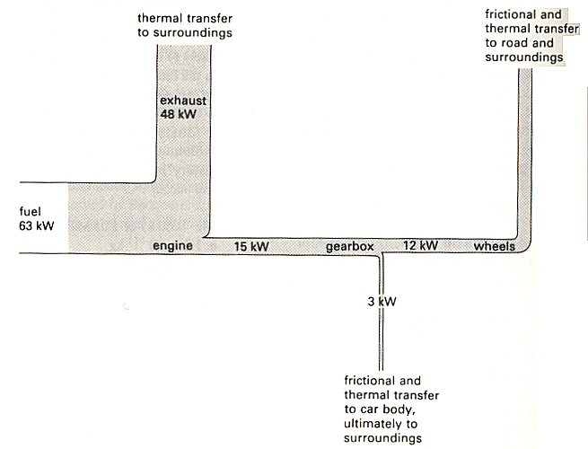
However, the diagrams can imply that each process happens consecutively, but that is not the case.

Questions
1. One litre of petrol produces 10 kWh. A car uses 7 litres per 100 km at a steady 90 km h⁻¹,the power output at the gearbox is 15 kW, and at the wheels 12 kW.
Use these data above to confirm the data in the Sankey diagram above.

2. Food, (fuel), is used by a human body in a number of ways, for example: keeping warm, doing external work, keeping parts of the body working, building body parts and inevitably some wastage
Construct a Sankey diagram to show this. (It will be mainly qualitative but remember input must equal output. (If you want to go further consider that in the UK an adult will have a daily intake of about 10 MJ. Consider how much energy is needed to say climb stairs, how much you radiate, [compare to a light bulb], and how efficient the body may be)

Hint
Your diagram could contain the following: 10 MJ input, digestive system, metabolism, output work, [say 3.6 MJ], maintaining body temperature, thermal transfer to surroundings, building body parts, breakdown of body parts and waste food.

Practical advice
Check to see that your specification requires Sankey diagrams.
You may wish to discuss the questions or set them as student problems.

Answers and worked solutions
1. Input: 7 litres at 10 kWh / litre = 70 kWh which is used to travel 100 km at 90 km h⁻¹. Thus input per hour is a rate of 70 x 9 / 10 = 63 kW

2.

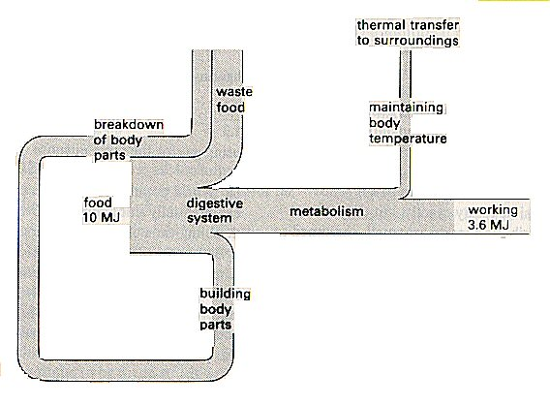
External References
This activity is based on Nuffield Revised Physics section G1 and question 2(L) and 3(E)
Episode 606-3: Student questions; calculating efficiency

1. What is the theoretical maximum efficiency of a heat engine which
(a) has a furnace at 2000 K and the surroundings at 300 K?

(b) runs on the 15 K difference between surface ocean water at about 288 K and deep water at nearly 273 K? Suggest why such an engine may be a good idea.

2. (a) The Birdsville geothermal power station starts with water at 98 °C and has a temperature of 30 °C at the condensers. What is the theoretical maximum efficiency?

(b) The energy transferred per second electrically by the power station is 80 kW. This is in fact 6% of energy transferred from the water per second. What was the energy transferred from the water per second?

(c) It is suggested that pumping more cold water to the hot rocks below would improve the output. Comment on this suggestion.

3. (a) A power station starts with steam at 543 °C and an output temperature of 100 °C
Calculate the maximum theoretical efficiency.

(b) The same site has a more modern system where the input steam temperature is 565 °C. By how much is the theoretical efficiency improved at the more modern site?

Practical advice
These are simple practice questions

Answers and worked solutions
1. (a) Maximum efficiency = (T_{HOT} – T_{COLD})/T_{HOT} = (2000 -300) / 2000 = 0.85 = 85%

(b) Maximum efficiency = (T_{HOT} – T_{COLD})/T_{HOT} = (288-273) / 288 = 0.052 = 5.2%
The temperature difference is maintained by the world climate, and affects large masses of water, so that a substantial amount of renewable energy might be extracted, provided that doing so did not materially affect the temperature gradient. Such a power station is called Ocean Thermal Energy Conversion (OTEC).

2. (a) Maximum efficiency = (T_{HOT} – T_{COLD})/T_{HOT} = ([98+273] – [30 + 273]) / [98 + 273]
= (371 – 303) / 371 = 0.183 =18.3%
(b) Efficiency = useful power out / total power in
so power in = power out / efficiency = 80 / 6% = 1333 kW
(c) The energy keeps on coming, as long as we don't pump too much cold water down and cool the rocks too much.

3. (a) Maximum efficiency = (T_{HOT} – T_{COLD})/T_{HOT} = ([543+273] – [100 + 273]) / [543 + 273]
= (816 – 373) / 816 = 0.54 = 54%

(b) Maximum efficiency = (T_{HOT} – T_{COLD})/T_{HOT} = ([565+273] – [273+100]) / [565 + 273]
= (838 – 373) / 838 = 0.67 = 67%
So efficiency is improved by 67% - 54% = 13%

External reference
Question 1 of this activity is from Nuffield Revised Physics unit K question 43(P)

